**Name:** Dev Kamlesh Bhanushali

**PRN:** 22070126032

**Java Assignment 3**

Student Management System

**Github:** <https://github.com/devilb2103/Sem-4/tree/main/Java/Assignments/Assignment3>

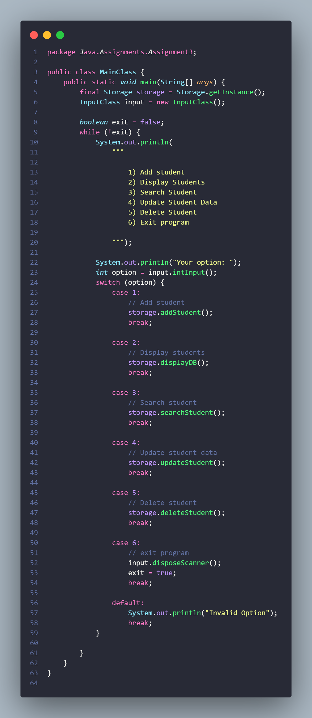 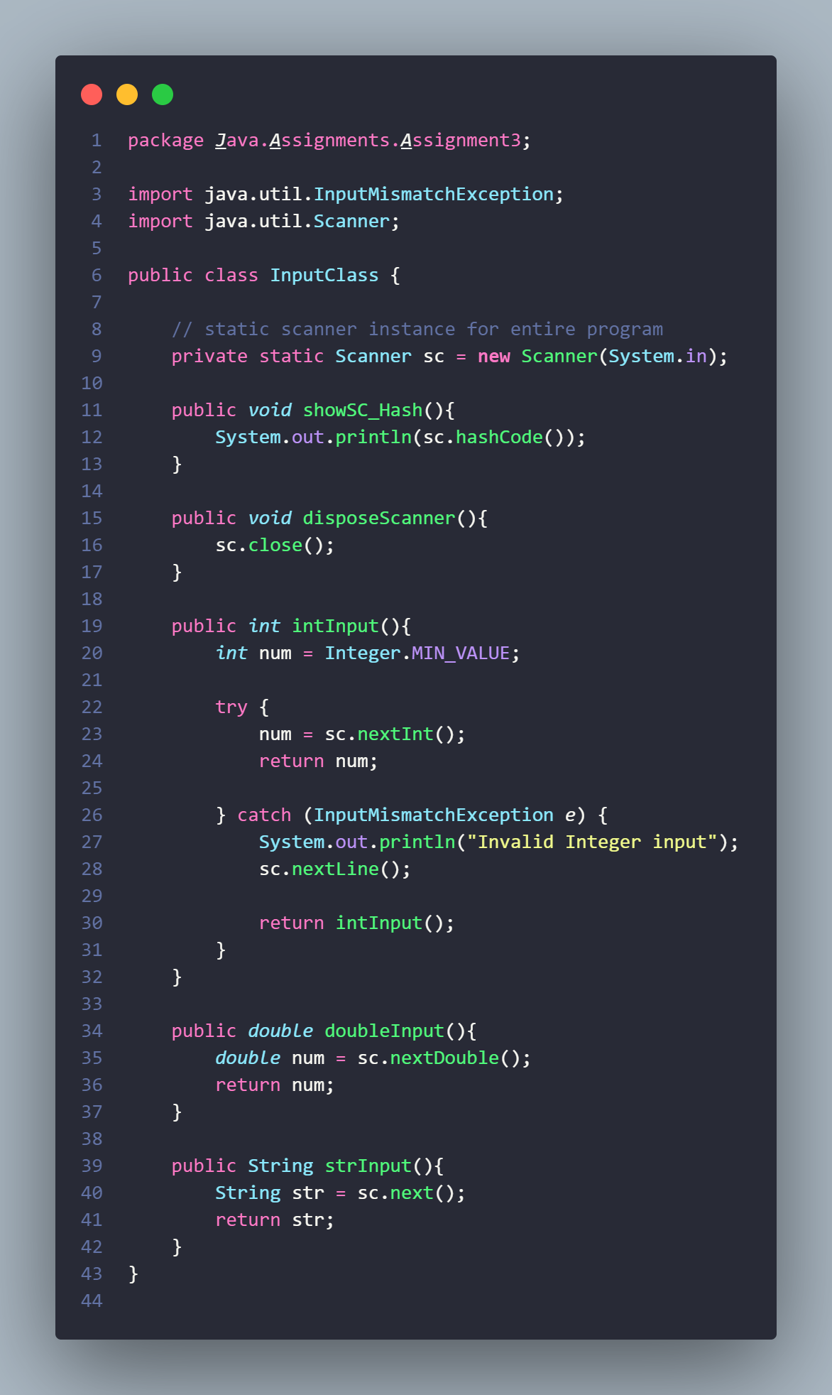

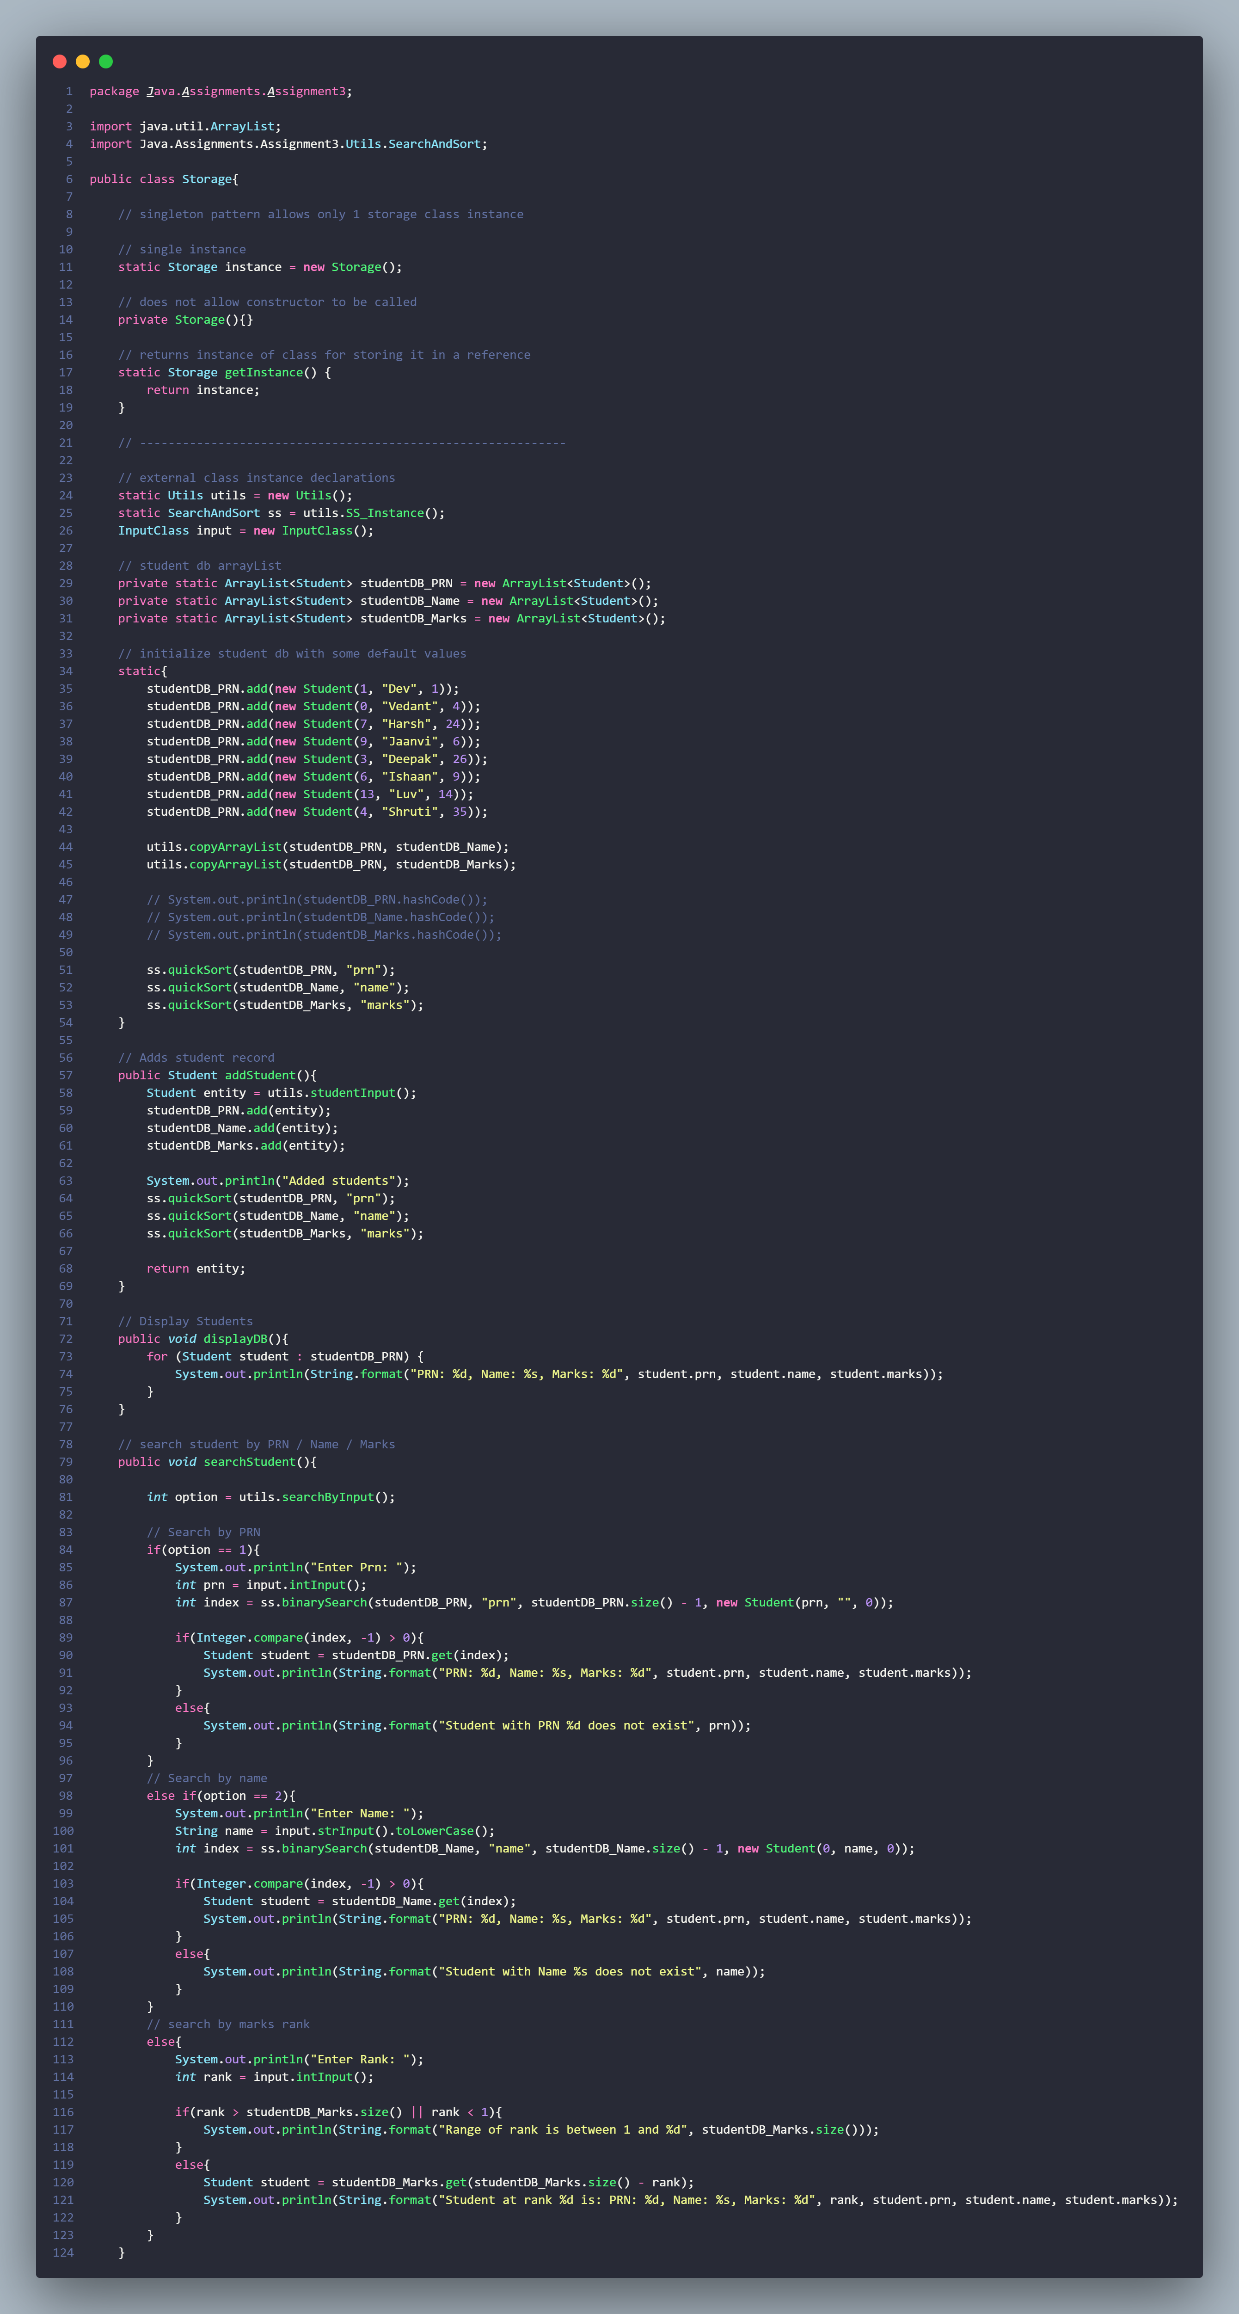

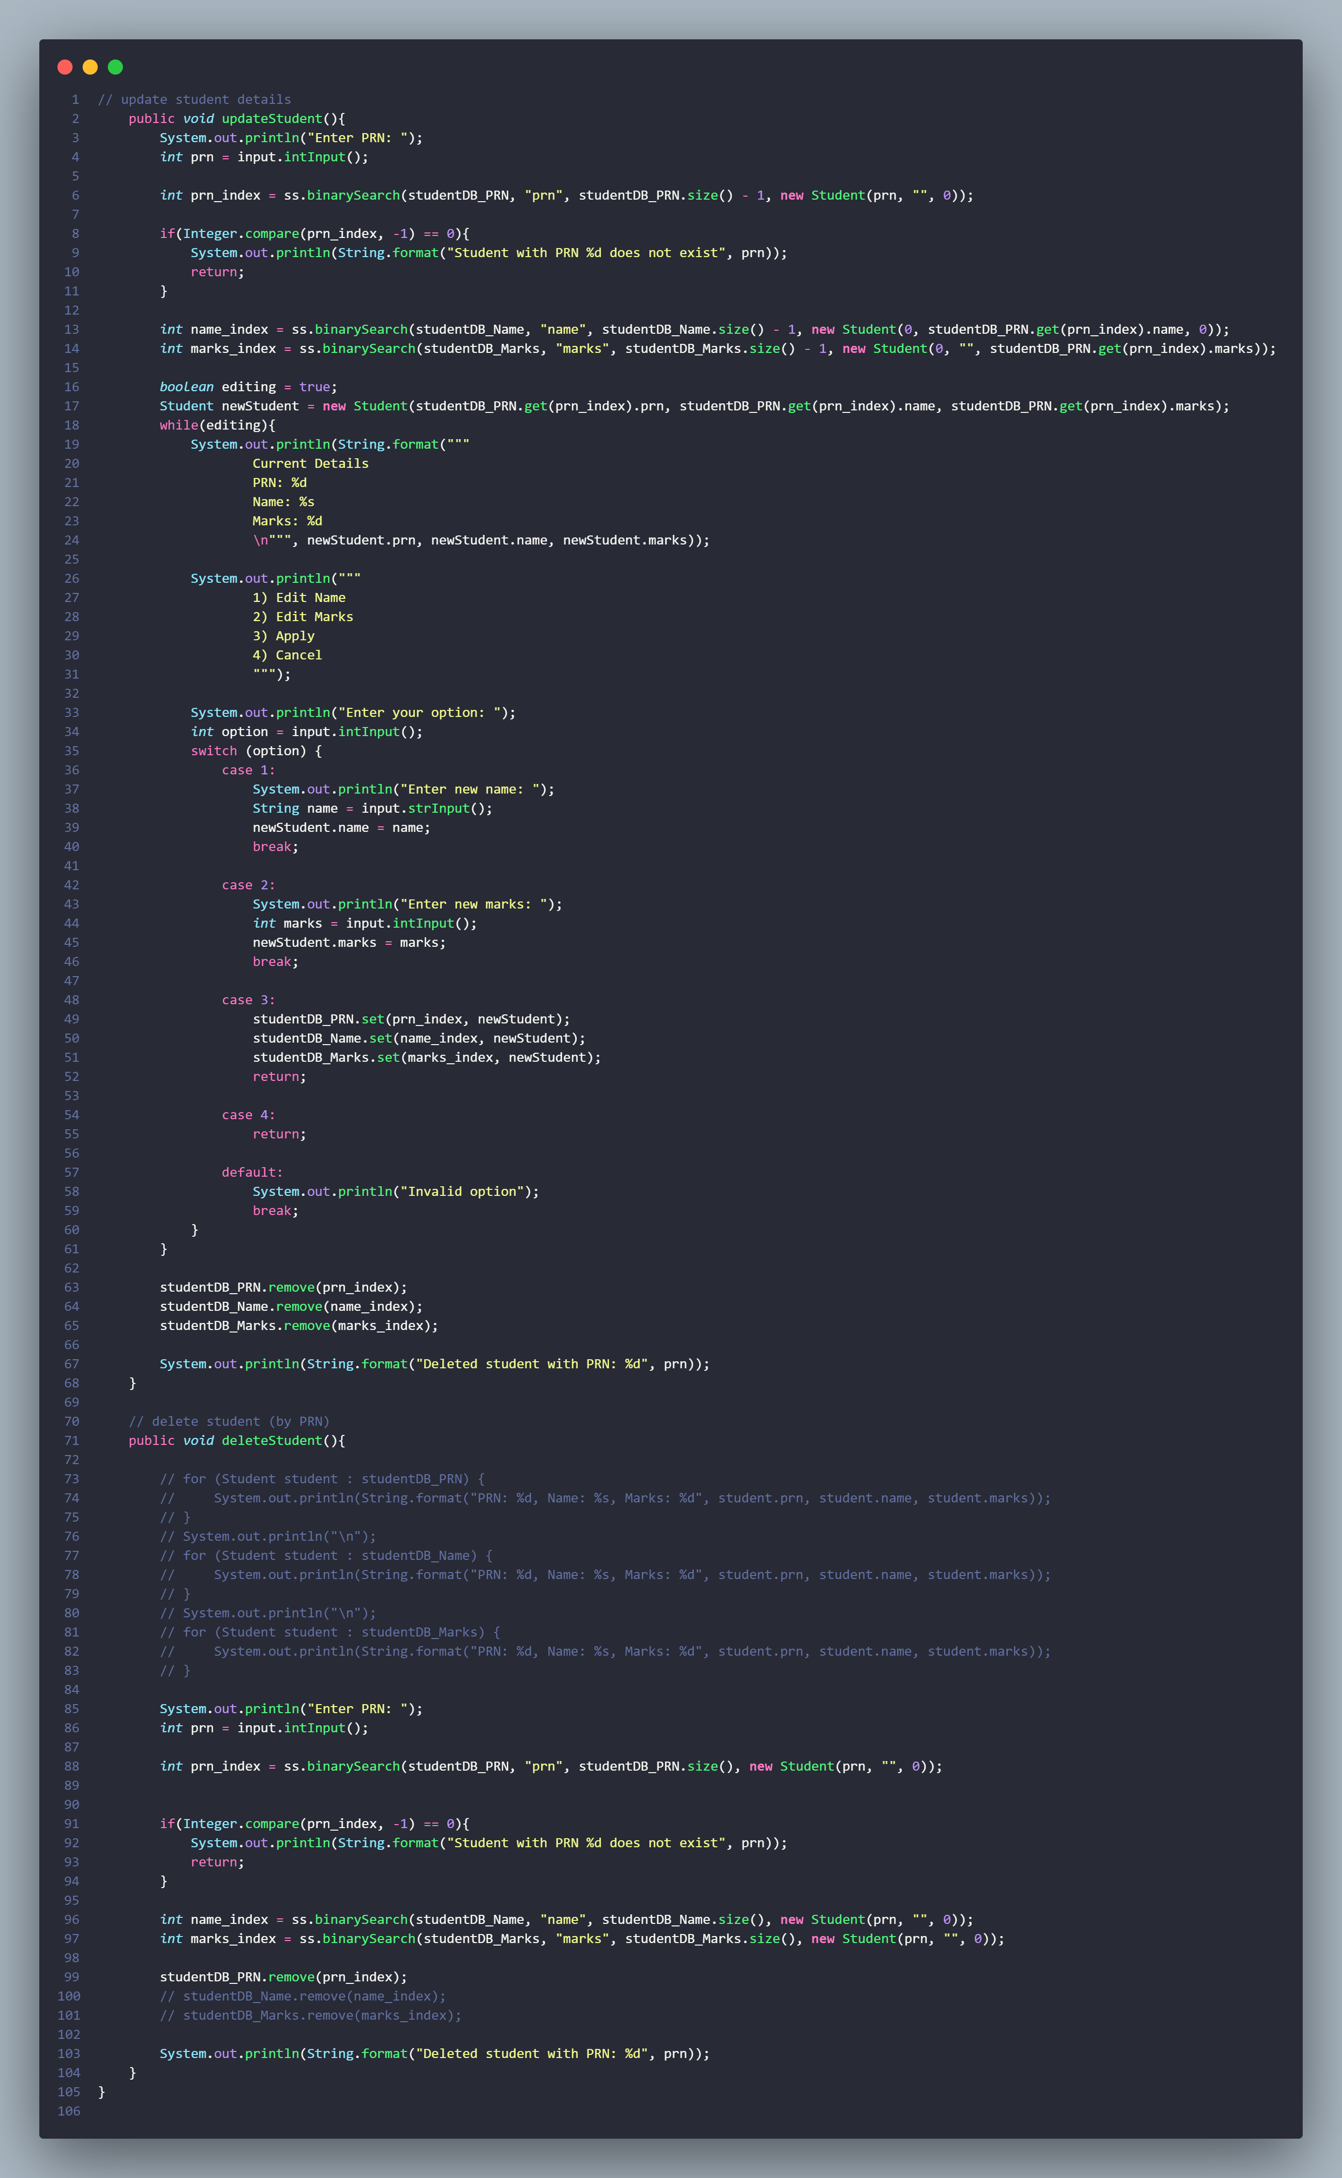

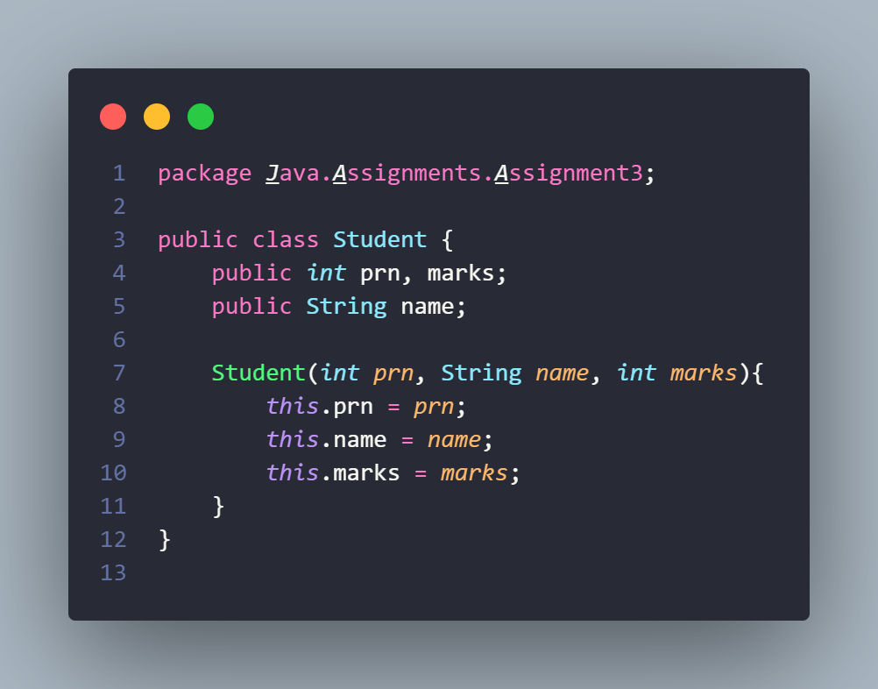

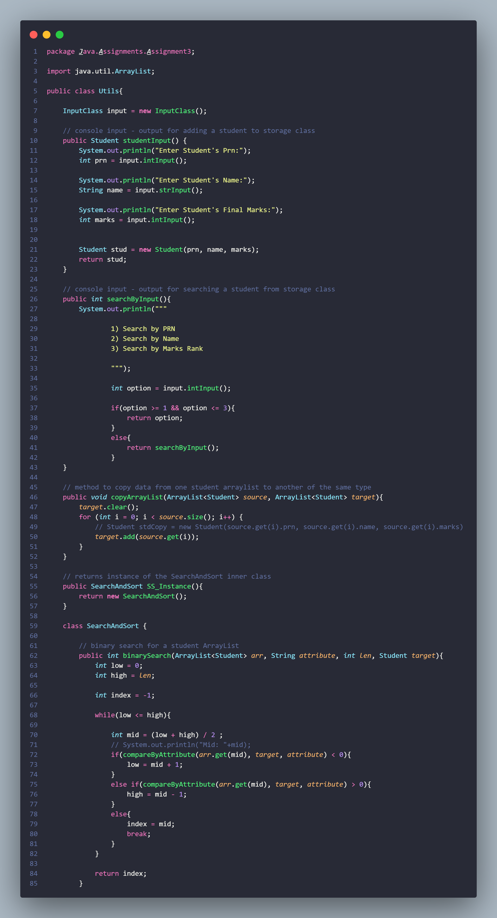 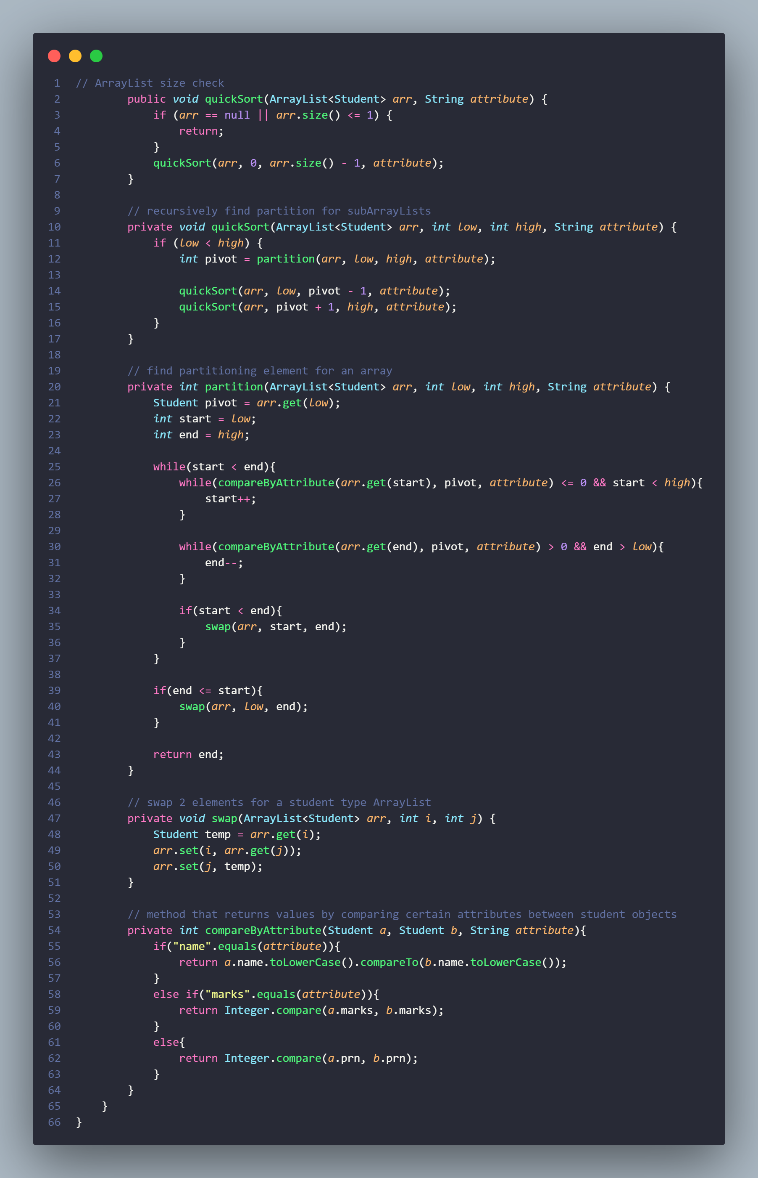

**Output**

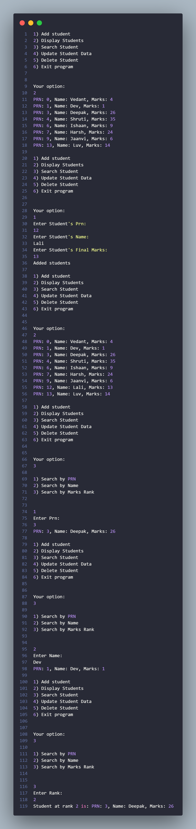 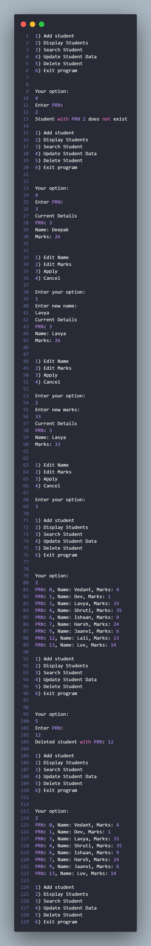

**Github:** <https://github.com/devilb2103/Sem-4/tree/main/Java/Assignments/Assignment3>